Developer Guide

jWebSocket
Remote Shell Demo 1.0
Yasmany Nuñez Broch

- Introduction
Remote Shell Demo is an application that allows remote control of computers in real time via the web. Making it easier for users to control the resources of a remote machine using a web interface that reflects the results in real time. It is an application that works on WebSocket communication protocol, which in conjunction with the jWebSocket framework provides precise results and high levels of speed and scalability.
jWebSocket is the framework on top of which the application was developed, showing the potential that it offers to make Web applications in real time.
- Infrastructure of the solution
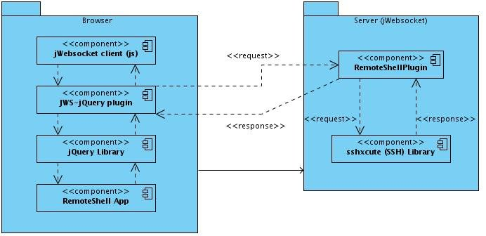

- The application sends and receives data via jQuery plugin JWS-which uses jWebSocket client written in JavaScript.
- The jWebSocket client communicates with the jWebSocket server via WebSocket protocol.
- The server contains the jWebSocket RemoteShellPlugin which manages the communication between the client and the remote machine.
- The plug-in in the server uses the library ssxcute to run the commands that were send from the client, get the results of their execution and sent to the client where they are finally shown.
Remote Shell Demo was developed using TokenPlugin. This is a lower-level structure where if you do not have many features and is easy to process messages, it is best to use since the application will benefit from increased performance.
- Structure of Source Code
Server side:
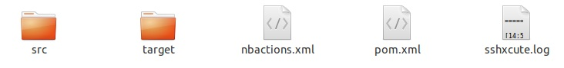
Elements description:
- src: This directory contains all the source code of classes and libraries of the solution.
- target: This directory temporarily stores the compiled source code, its content is not included in the version control.
- pom.xml: Configuration file for jWebSocketServer module that contains information about the project and details of the settings used by Maven to build the project.
- sshxcute.log: File where the library stores the logs of the application.
Client side:
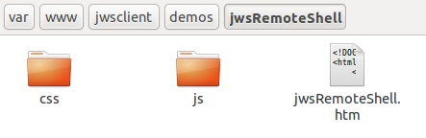
Elements description:
- css: This directory contains the css file and a directory with the images used in the application.
- js: This directory contains the js file used for application development.
- jwsRemoteShell.htm: It is a hypertext file. These are usually static content, not dynamic. Includes the HTML of the application.

- Modularization of the application
Server side:
Project name: | Remote Shell Demo
Location of the sources in the SVN server: | https://jwsdev.org:9443/svn/jWebSocket/thesis/RemoteShellDemo/Implementation
SVN branch: | jWebSocket-1.0
Maven Dependency: | 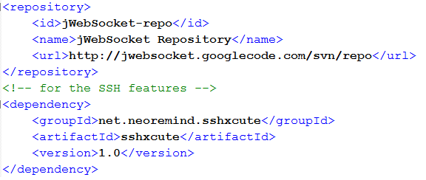
JAR Module: | jWebSocketRemoteShellPlugIn-1.0.jar
Packet structure: | namespaces: org.jwebsocket.plugins.remoteshelldemo  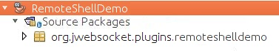
org.jwebsocket.plugins.remoteshelldemo:
Contains the core classes of the module that allows remote management of computers for jWebSocket framework.

Client side:
The client libraries and classes for Remote Shell Demo are available only to the JavaScript language and are stored in the folder jWebSocket/thesis/RemoteShellDemo/Implementation/Client.
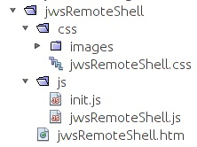

On the client side makes uses the following JavaScript file:
- jwsRemoteShell.js: Can handle the features of the console with the data coming from the server.
Also makes use of css and html files for the application user interface:
- jwsRemoteShell.html: In this file is defined all html code.
- jwsRemoteShell.css: In this file is defined the special css code of the elements that appears only in this application.

